Steven Metcalf

CIT263

Kurt Johnson

5/15/2019

Final Project Information

**Web Service Client:**

**Classes**

**frmPresentation** – This class is a windows form object that handles user input and displays results. It has 6 subroutines:

*btnHello_World_Click*

This calls the HelloWorld() function from the Business class and displays the result as a message box.

*btnSelect_Click*

This clears the contents of the listview, calls the CustomerSelect() function of the business class, and adds the results to the listview.

*btnUpdate_Click*

This validates user input before calling the CustomerUpdate() function of the Business class.

*btnInsert_Click*

This validate user input before calling the CustomerInsert() function for the Business calls. Displays whether the customer was added successfully in a messagebox.

*btnDelete_Click*

This checks to make sure the input was numeric, calls the CustomerDelete() function of the business class, and informs the user whether the customer could be deleted.

**Business –** This class handles interaction between the client and the server, retrieves information and sends calls to have the information logged by the persistence class and displayed by frmPresentation. It has 5 functions:

*HelloWorld*()

This Function converts the result from the HelloWorld Web Service into a string, has it logged, and returns the result to frmPresentation.

*CustomerSelect*()

This function creates a new Customer object with information provided by frmPresentation. It then calls the CustomerSelect() web method with that customer. Finally it formats the result as a Tuple, has it logged, and sends the formatted results back to frmPresentation.

*CustomerUpdate*()

This function creates a new Customer object with information provided by frmPresentation, has it logged, and sends the results of the CustomerWrite() webmethod back to frmPresentation.

*CustomerInsert*()

This function creates a new Customer object with information provided by frmPresentation, has it logged, and sends the results of the CustomerInsert() webmethod back to frmPresentation.

*CustomerDelete*()

This function calls the CustomerDelete() webmethod, has the deleted customerID logged and returns the result.

**Persistence –** This class handles the logging of interactions between the web client and web server. It has 5 subroutines:

*LogHelloWorld*()

This function uses a StreamWriter to append “Hello World Statement: Successful” to the log file.

*LogSelect*()

This function uses a StreamWriter to append the statement type and SELECT criteria to the log file.

*LogInsert*()

This function uses a StreamWriter to append the statement type and new customer information to the log file.

*LogUpdate*()

This function uses a StreamWriter to append the statement type and updated information to the log file.

*LogDelete*()

This function uses a StreamWriter to append the statement type and CustomerID deleted to the log file.

**Web Service Server:**

**Web Methods**

*HelloWorld*()

This function reads and returns the result of a helloWorld API call.

*CustomerDelete*()

This function reads and returns the result of a deleteCustomer API call for a given customerID.

*CustomerInsert*()

This function reads the result of an insertCustomer api call with parameters names, address1, address2, city, state, and zip. It then parses the result and returns the status and customerID of the new customer.

*CustomerSelect*()

This function creates a call to the selectCustomer API method and builds onto the string based on which properties of a given customer object are not empty. It then calls the API, before deserializing and returning the result.

*CustomerWrite*()

This function creates a call to the updateCustomer API method and builds onto the string based on which properties of a given customer object are not empty. It then calls the API, before parsing and returning the status.

**Classes**

Customer – This class is carrier for a given customer record. It contains 8 fields as properties:

*Fields*

* Name
* Address1
* Address2
* City
* State
* Zip
* Status
* Customer_id

**Screenshots**

*HelloWorld*

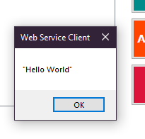

*Select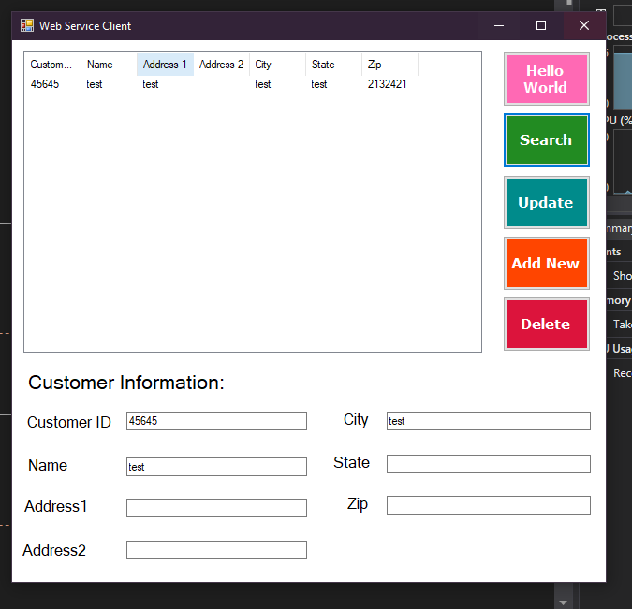*

*Add* *New*

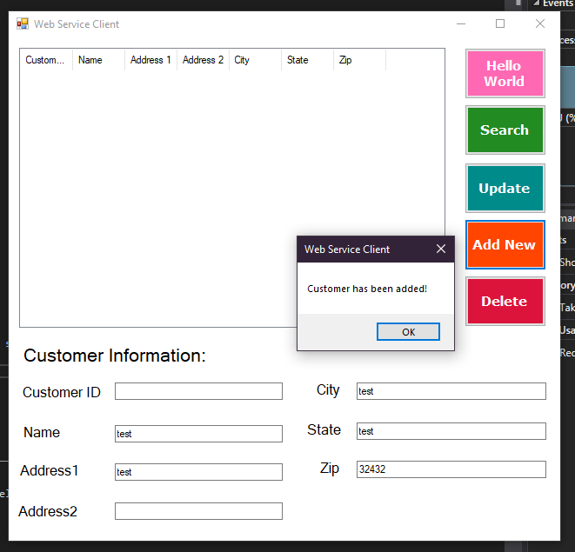

*Update*

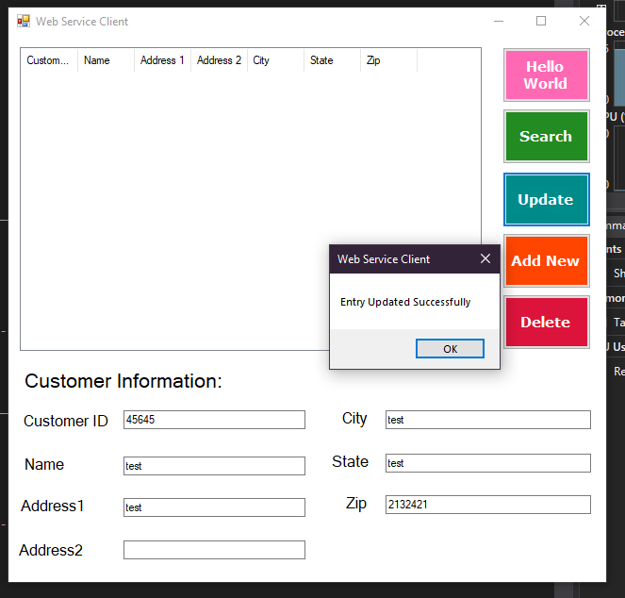

*Delete*